**1)package** project2;

**public** **class** sumofintergers {

**public** **static** **void** main(String[] args)

{

**int** count=0;

**int** sum=0;

**for**(**int** i=101;i<200;i++)

{

**if**(i%7==0)

{

sum=sum+i;

}

}

System.***out***.println("My sum is"+ " "+ + sum);

}

}

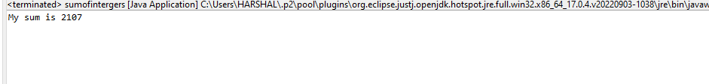

**3)package** project2;

**import** java.util.Scanner;

**public** **class** asciivalue {

**public** **static** **void** main(String[] args) {

**char** x;

Scanner s=**new** Scanner(System.***in***);

System.***out***.println("enter any character");

x=s.next().charAt(0);

**int** ascii=x;

System.***out***.println("ascii value of character :"+ " "+ ascii);

}

}



**2)package** project2;

**import** java.util.Scanner;

**public** **class** greatestnum {

**public** **static** **void** main(String[] args) {

**int** num1;

**int** num2;

**int** num3;

Scanner s = **new** Scanner(System.***in***);

System.***out***.println("Enter num1");

num1=s.nextInt();

System.***out***.println("Enter num2");

num2=s.nextInt();

System.***out***.println("Enter num3");

num3=s.nextInt();

**if**(num1>num2 && num1>num3)

System.***out***.println("Num1 is greater");

**else** **if**(num2>num1 && num2>num3)

System.***out***.println("Num2 is greater");

**else**

System.***out***.println("Num3 is greater");

}

}

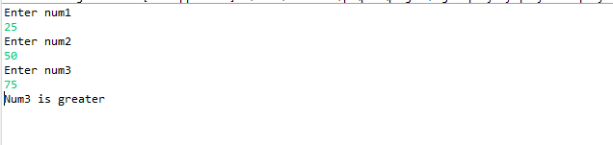

**4)package** project2;

**import** java.util.Scanner;

**public** **class** vpwelconsonanr {

**public** **static** **void** main(String[] args) {

**char** ch;

Scanner s = **new** Scanner(System.***in***);

System.***out***.println("Enter alphabet:");

ch =s.next().charAt(0);

**if**(ch =='a'||ch=='e'||ch=='i'||ch=='o'||ch=='u')

System.***out***.println("Alphabet is vowel");

**else**

System.***out***.println("Alphabet is consonant");

}

}

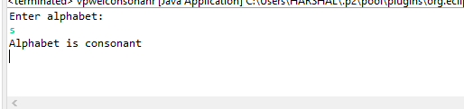

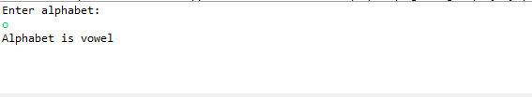

**5)package** project2;

**import** java.util.Scanner;

**public** **class** postnegtnum {

**public** **static** **void** main(String[] args) {

**int** num;

Scanner s = **new** Scanner (System.***in***);

System.***out***.println("Enter num:");

num = s.nextInt();

**if**(num>0)

System.***out***.println(num + " "+ " is positive");

**else**

System.***out***.println(num + " "+ " is negative");

}

}

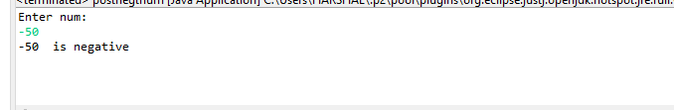

**6)package** project2;

**import** java.util.Scanner;

**public** **class** swapping {

**public** **static** **void** main(String[] args) {

**int** num1;

**int** num2;

Scanner s = **new** Scanner (System.***in***);

System.***out***.println("Enter num1");

num1 = s.nextInt();

System.***out***.println("Enter num2");

num2 = s.nextInt();

num1=num1+num2;

num2=num1-num2;

num1=num1-num2;

System.***out***.println("After Swapping"+" "+num1+" "+ num2);

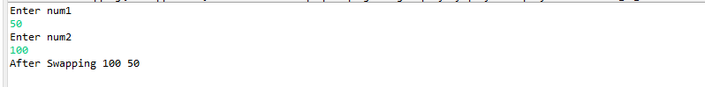

**8)package** project2;

**public** **class** evennum {

**public** **static** **void** main(String[] args) {

**for**(**int** i=10;i<=20;i++)

{

**if**(i%2==0)

System.***out***.println(i);

}

}

}

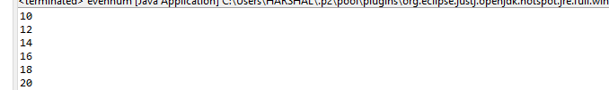

**10)package** project2;

**public** **class** reversedigit {

**public** **static** **void** main(String[] args) {

**int** num=123;

**int** reverse=0;

**for**( ;num!=0;num/=10)

{

**int** digit = num % 10;

reverse=reverse*10+digit;

}

System.***out***.println("Reverse no"+ " " + reverse);

}

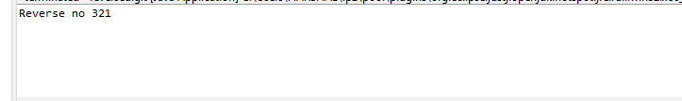

**9)package** project2;

**import** java.util.Scanner;

**public** **class** primenum {

**public** **static** **void** main(String[] args) {

**int** n;

**int** count =0;

Scanner s = **new** Scanner (System.***in***);

System.***out***.println("Enter value of n");

n = s.nextInt();

**for**(**int** i=1;i<=n;i++)

{

**if**(n%i==0)

{

count++;

}

}

**if**(count==2)

{

System.***out***.println("Number is prime");

}

**else**

{

System.***out***.println("Number is not prime");

}

}

}

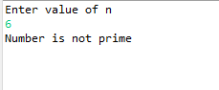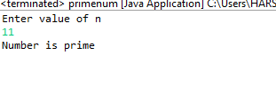

---------------------------------------------------------=----------------------

**8)package** project2;

**import** java.util.Scanner;

**public** **class** basicsalary {

**public** **static** **void** main(String[] args) {

**int** salary;

**int** grosssal;

**int** HRA;

**int** DA;

Scanner s= **new** Scanner(System.***in***);

System.***out***.println("Enter salary");

salary=s.nextInt();

**if**(salary<=10000)

{

HRA=(salary*20)/100;

DA=(salary*80)/100;

grosssal=salary+HRA+DA;

System.***out***.println("My grosssalary is"+" "+ grosssal);

}

**else** **if**(salary<=20000)

{

HRA=(salary*25)/100;

DA=(salary*90)/100;

grosssal=salary+HRA+DA;

System.***out***.println("My grosssalary is"+" "+ grosssal);

}

**else** **if**(salary>20000)

{

HRA=(salary*30)/100;

DA=(salary*95)/100;

grosssal=salary+HRA+DA;

System.***out***.println("My grosssalary is"+" "+ grosssal);

}

}

}

